**DATA WAREHOUSING AND BUSINESS INTELLIGENCE**

**ASSIGNMENT-4**

**Name: Vedant Desai**

**NUID: - 001830150**

1. Editing Excel File and converting into tab deiminated file for further tasks.

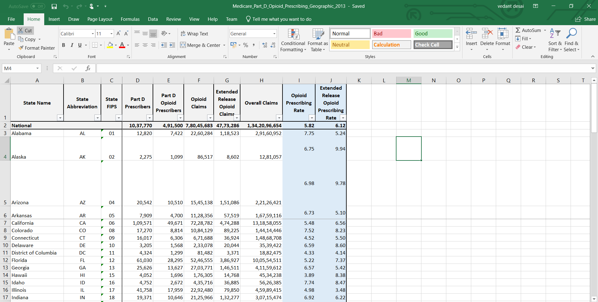

1. Creating variables to use in package.

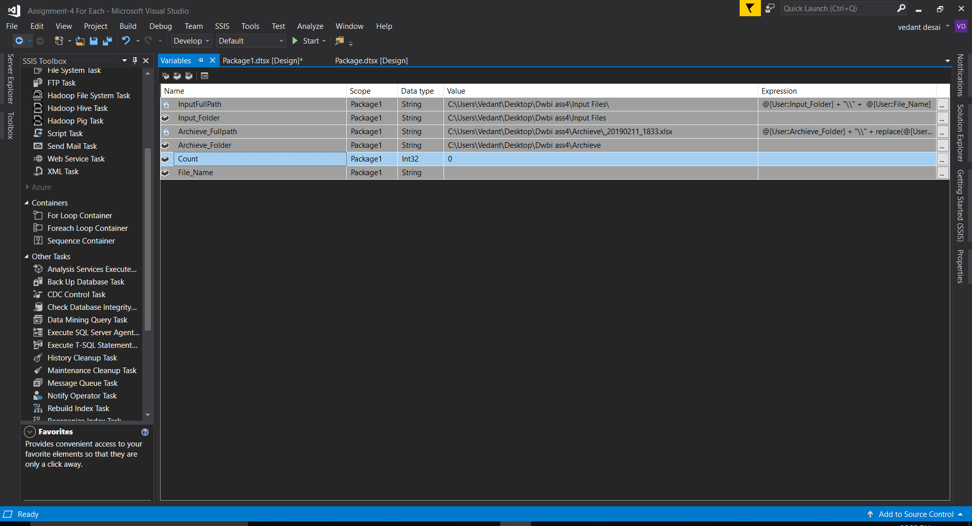

1. Now, Creating a flat file source in “for-each-loop” to read all Opiod medicare files and transfering them into staging table for temporary purpose.

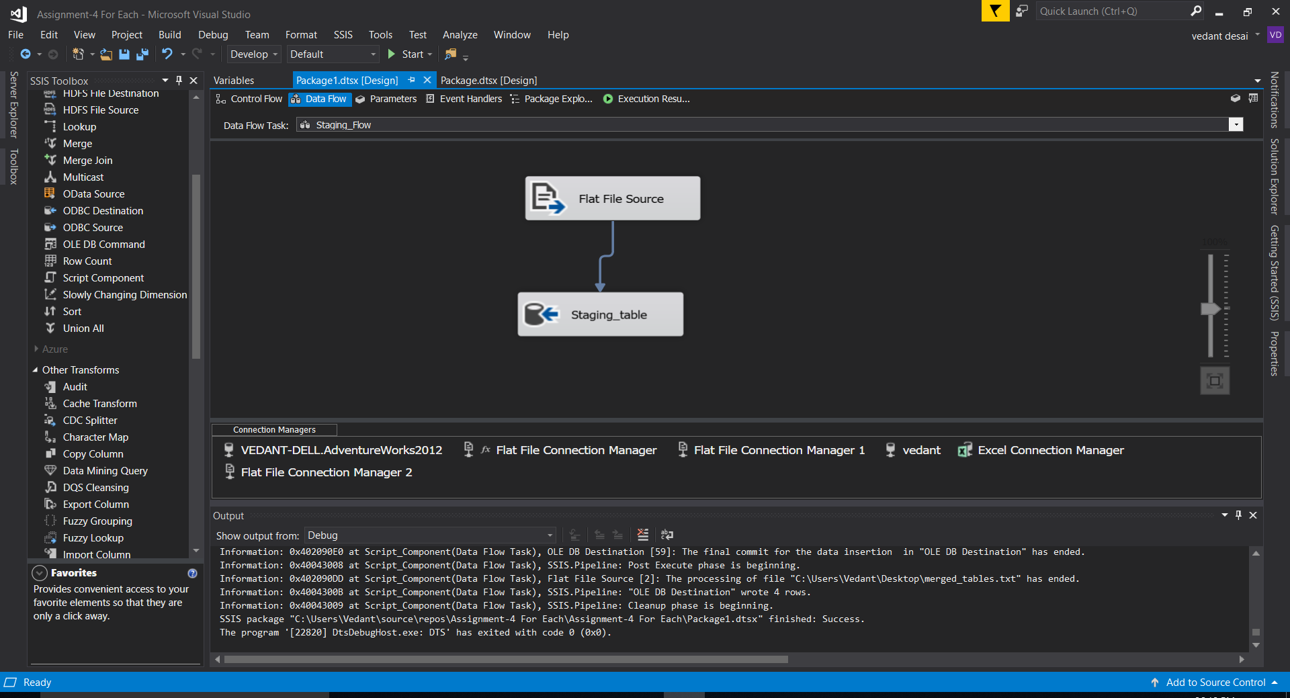

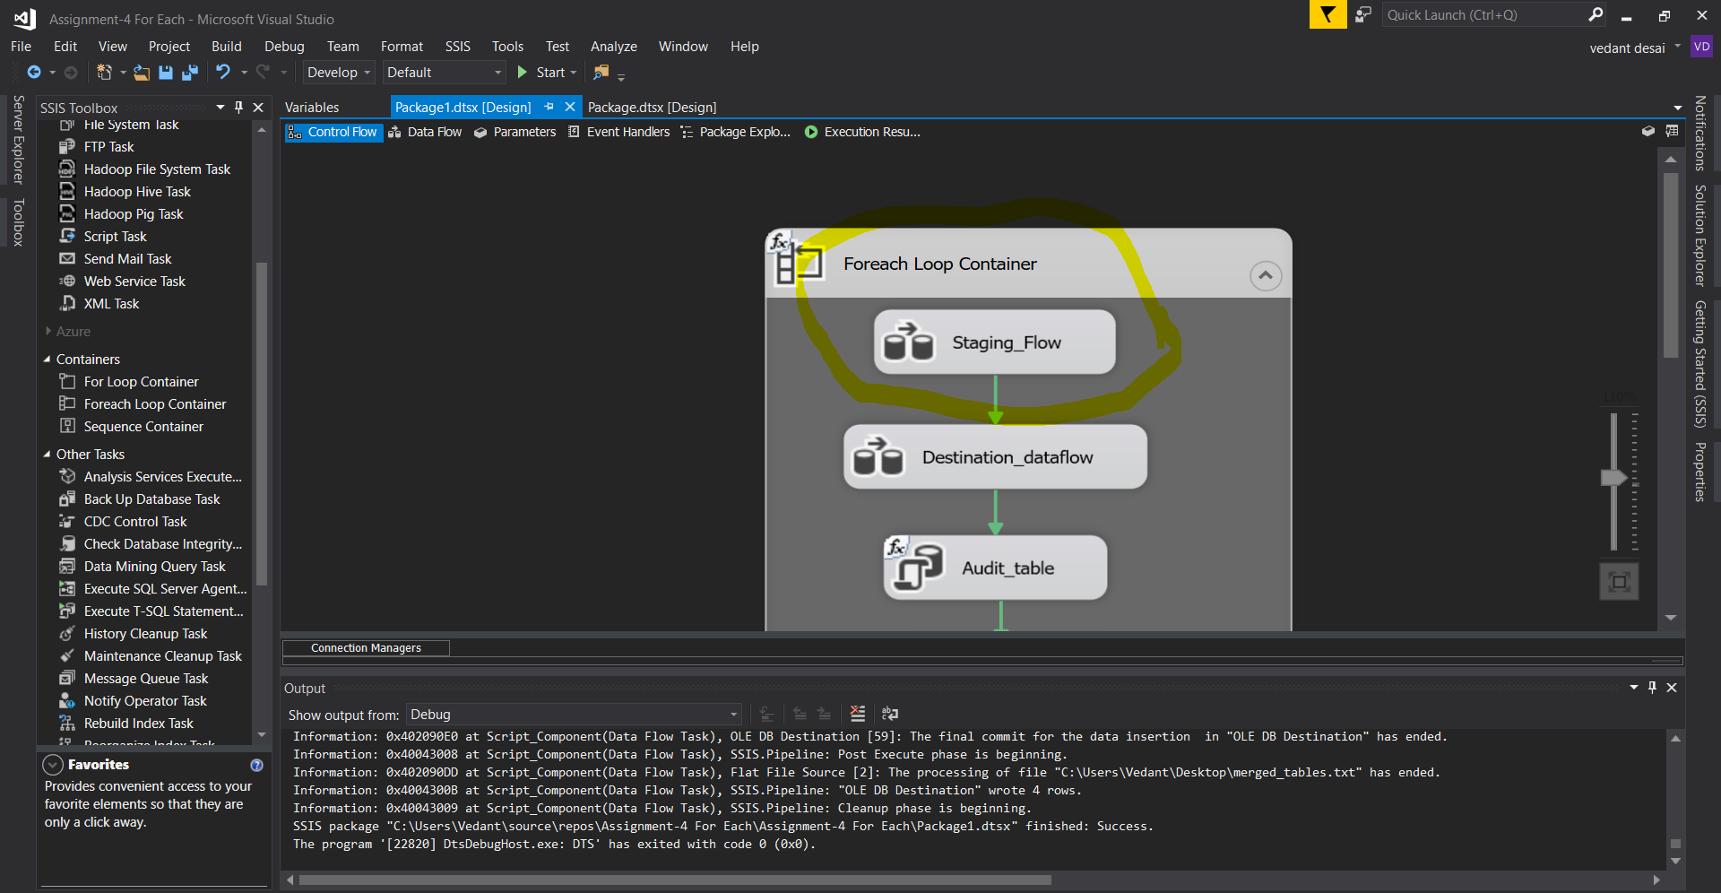

1. Creating a parameter for input full path for reading all flat files.

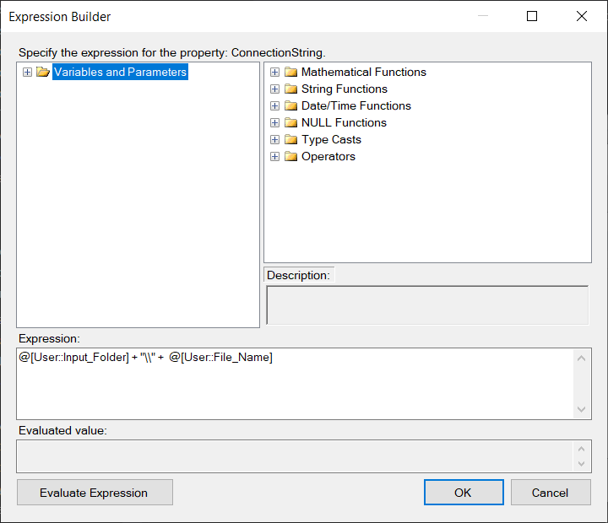

1. Setting the properties for For-each-loop and setting a directory for input folder. As we created a file path for just one file and we want to load all 4 files together, so we will set a expression in for-each loop to read files ending with .txt.

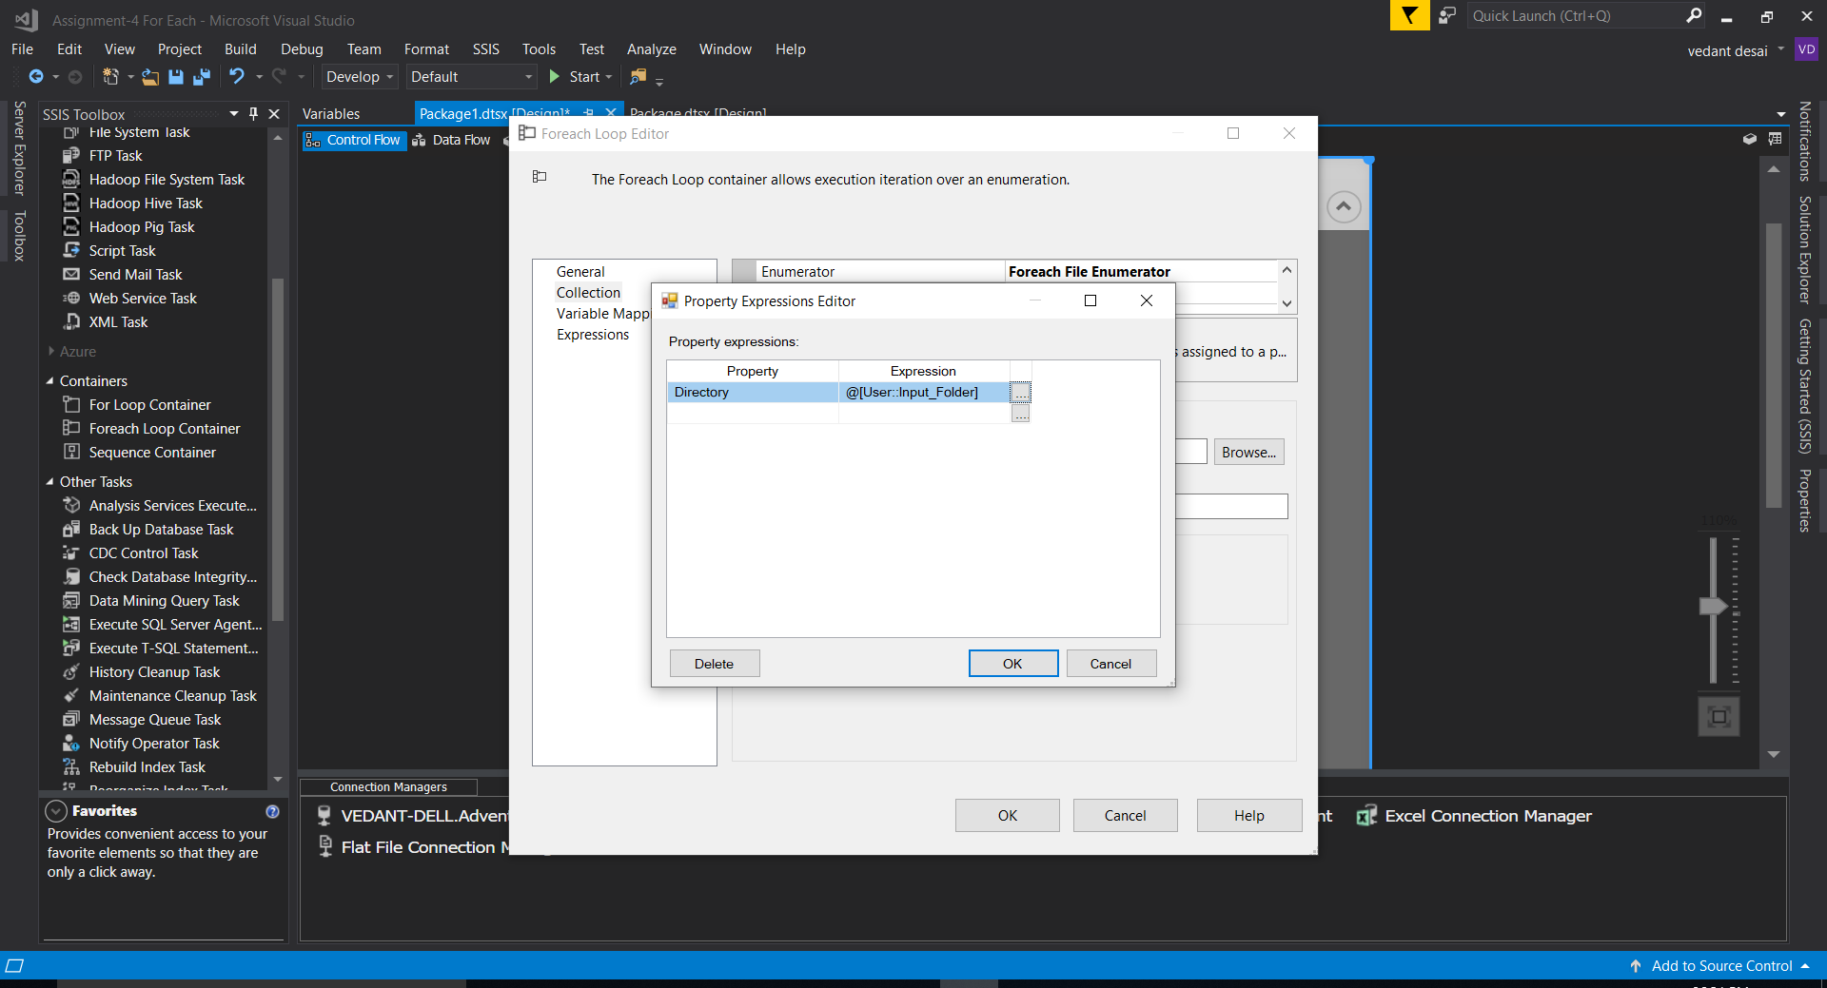

1. Now, taking a source as staging table and adding “File_name” and “Date” column in derived transformation. Further, taking a row count transformation and assigning a count variable to it. It will count the load of each file with a date and filename and store it in Audit table.

In staging we have a row with “Total National Rows” and we don’t want it in our destination table. So, we are creating a conditional split and setting up a condition which will give us a above result.

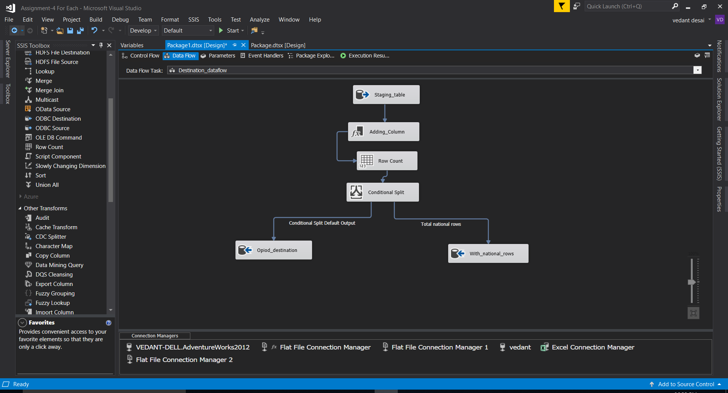

1. Setting a Properties for audit table and giving a expression for insert.

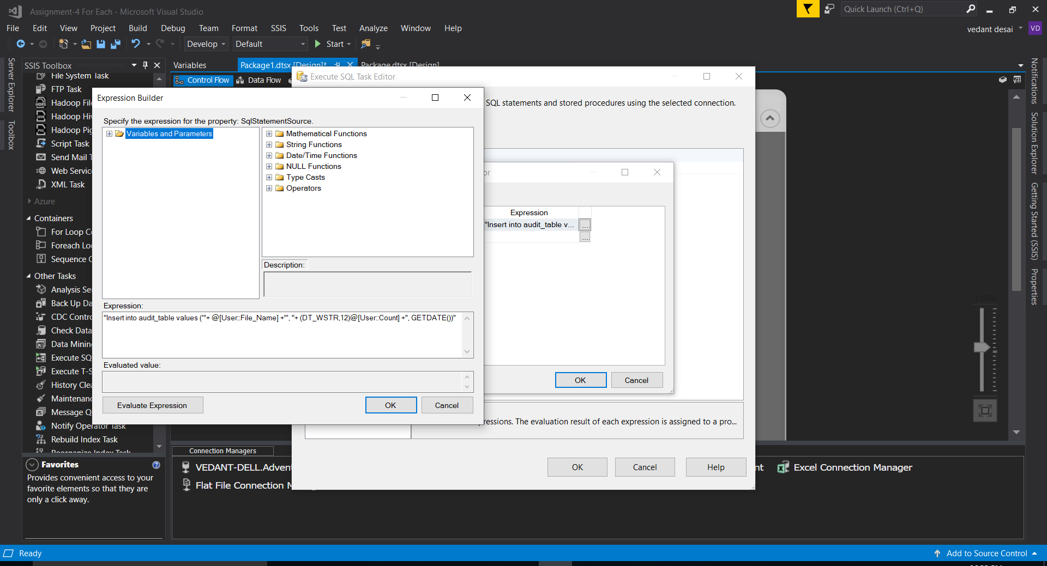

1. Now taking a Data flow task name as “Aggregate” which will do the sum of all the destination columns. We are using it for validation purpose.

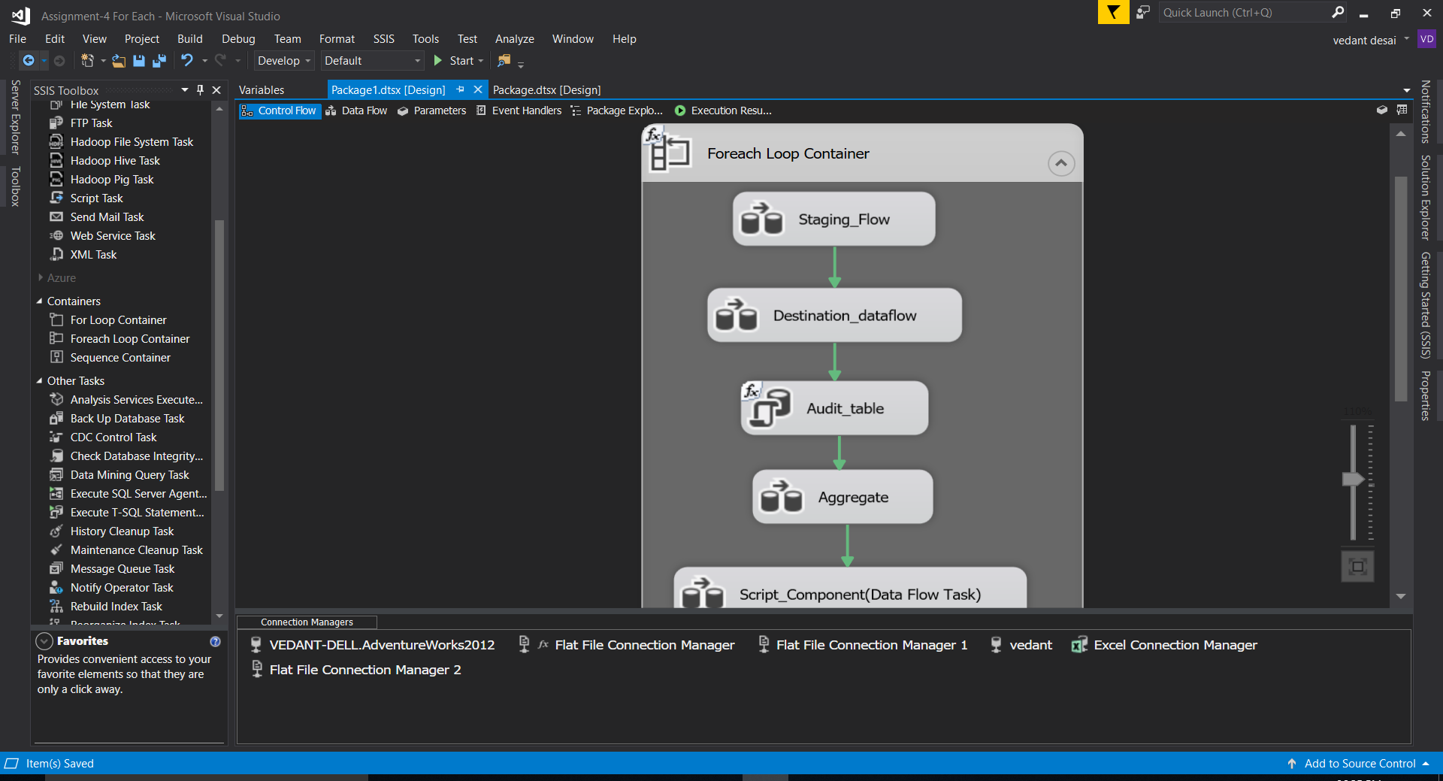

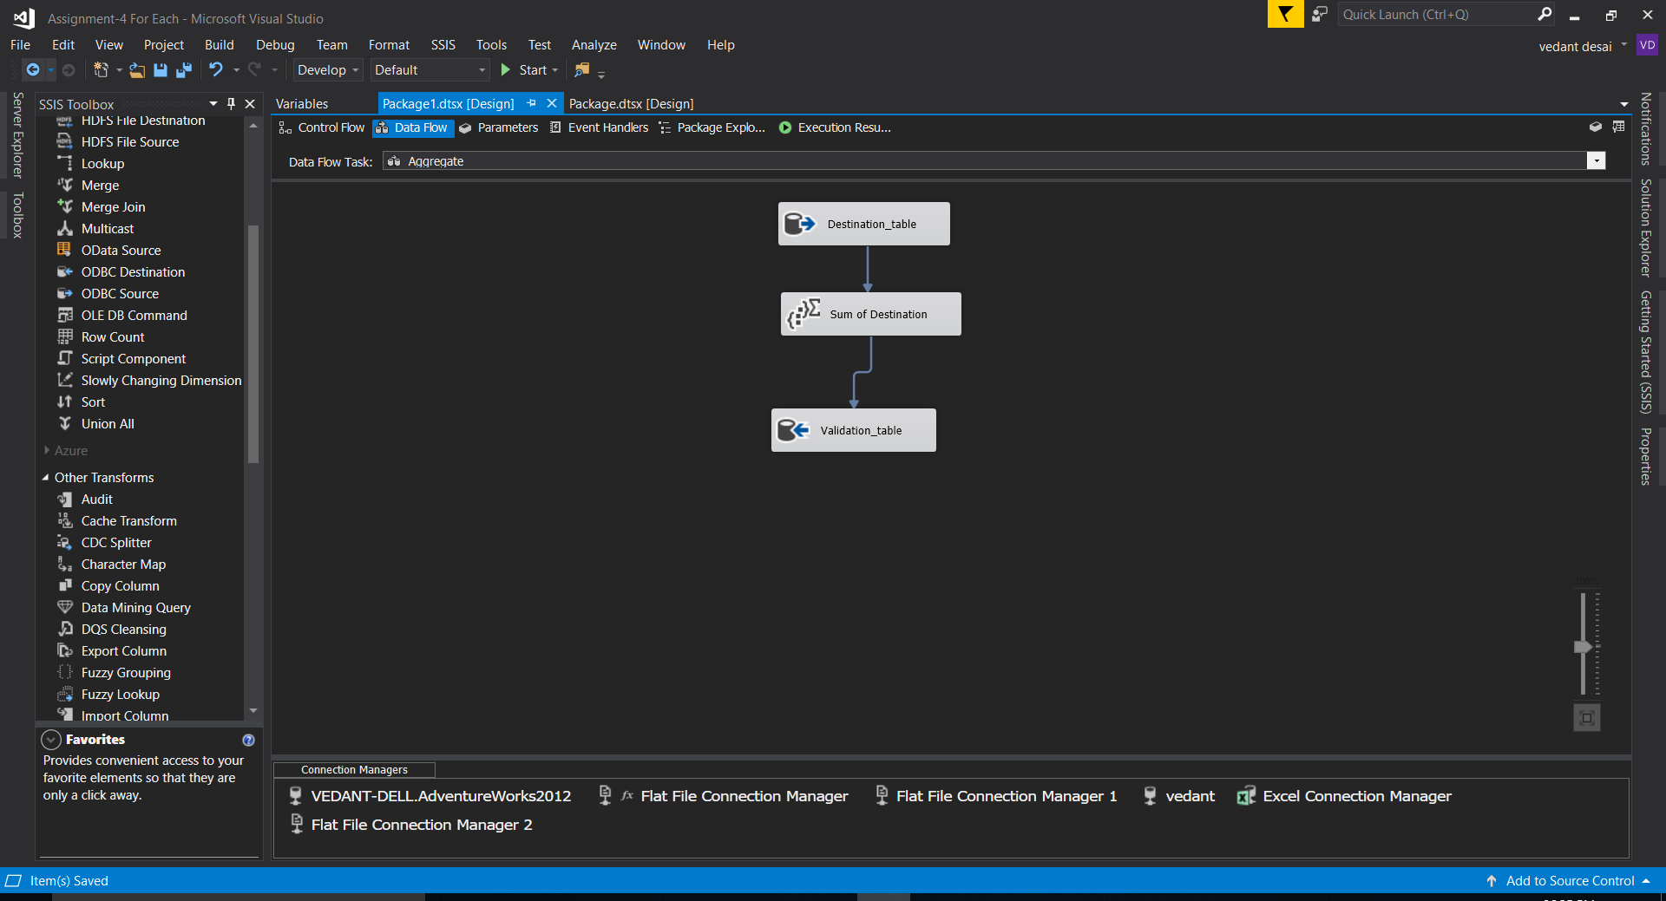

1. Using a Script Component task and using a C# for validation Purpose.

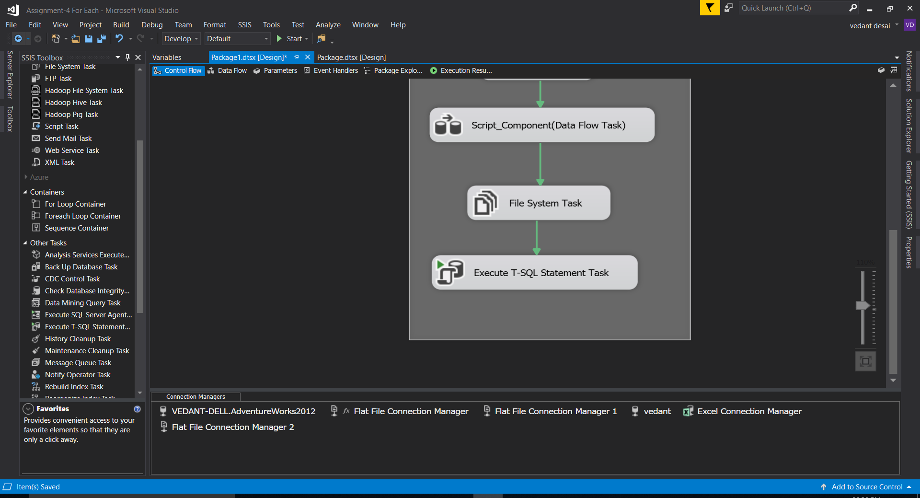

1. Creating a public class and a variable “Message” which will print a status of validation.

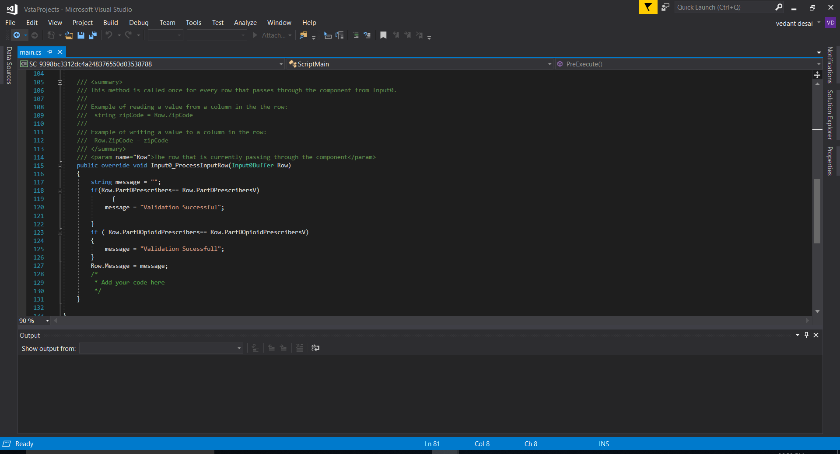

1. I merged 2 tables, destination table and table with national rows. Now using script component, result table will store the result of validation.

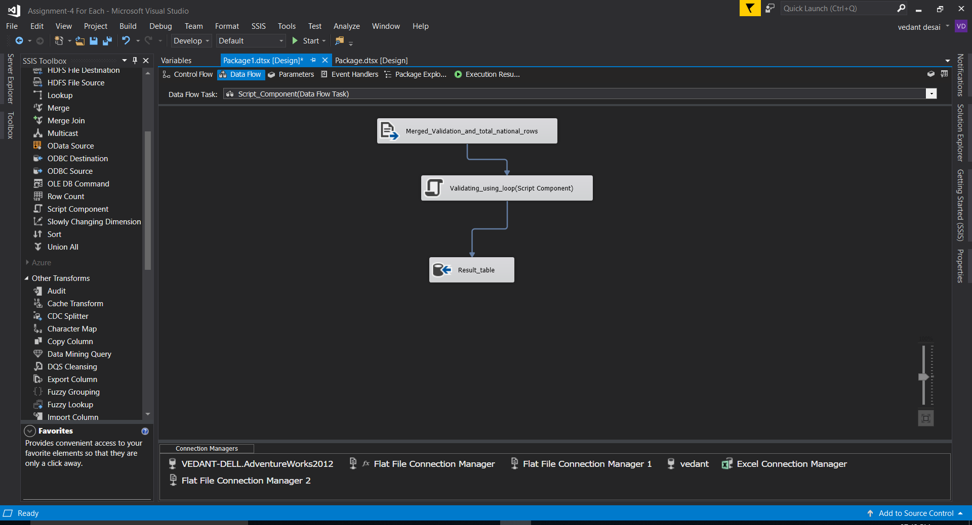

1. Now it will compare the columns of both the tables and generate the result as “Validaton Successful” or not.

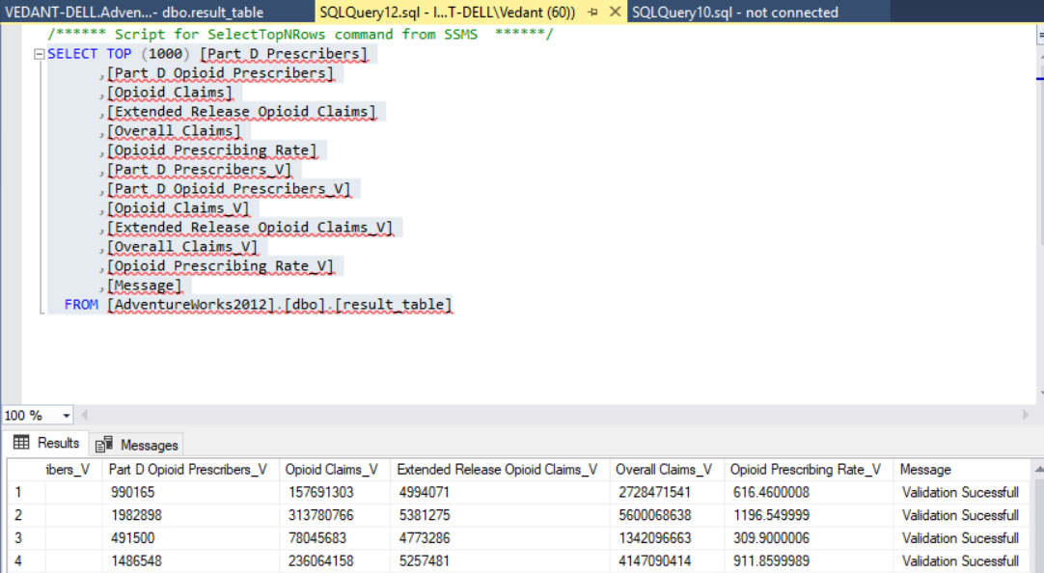

1. Now for archiving we will use file system task.



1. I have created an archive area which will take all the files from input folder.

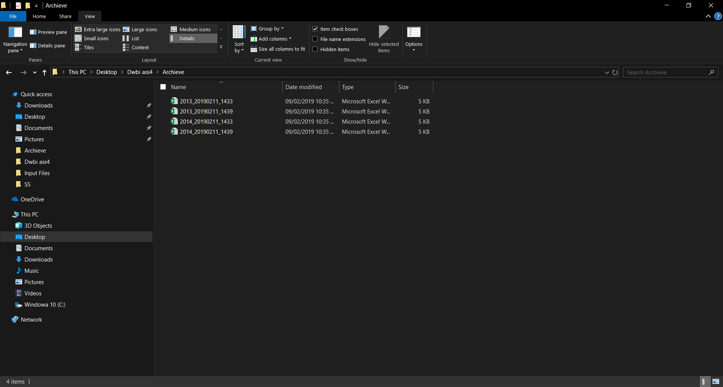

1. Now setting up an expression for file system task by variables archive_full_path and archive folder.

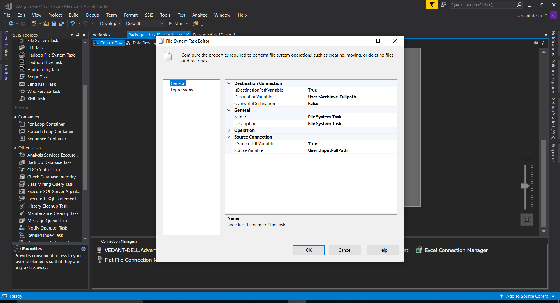

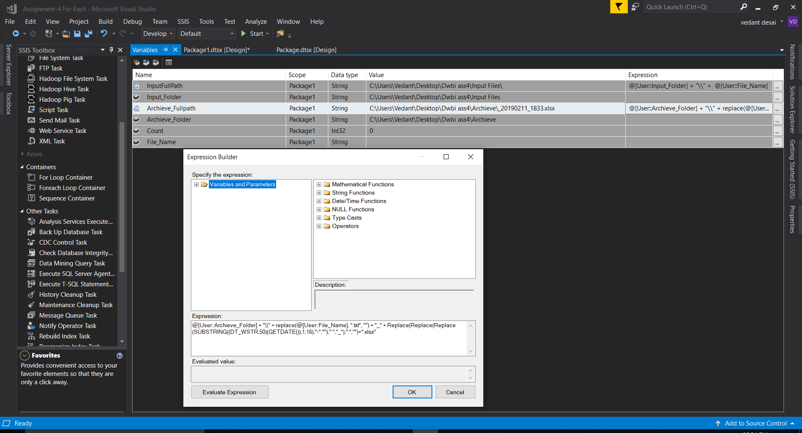

1. Executing T-SQL task for general truncate statement. It will truncate staging table after each loop.

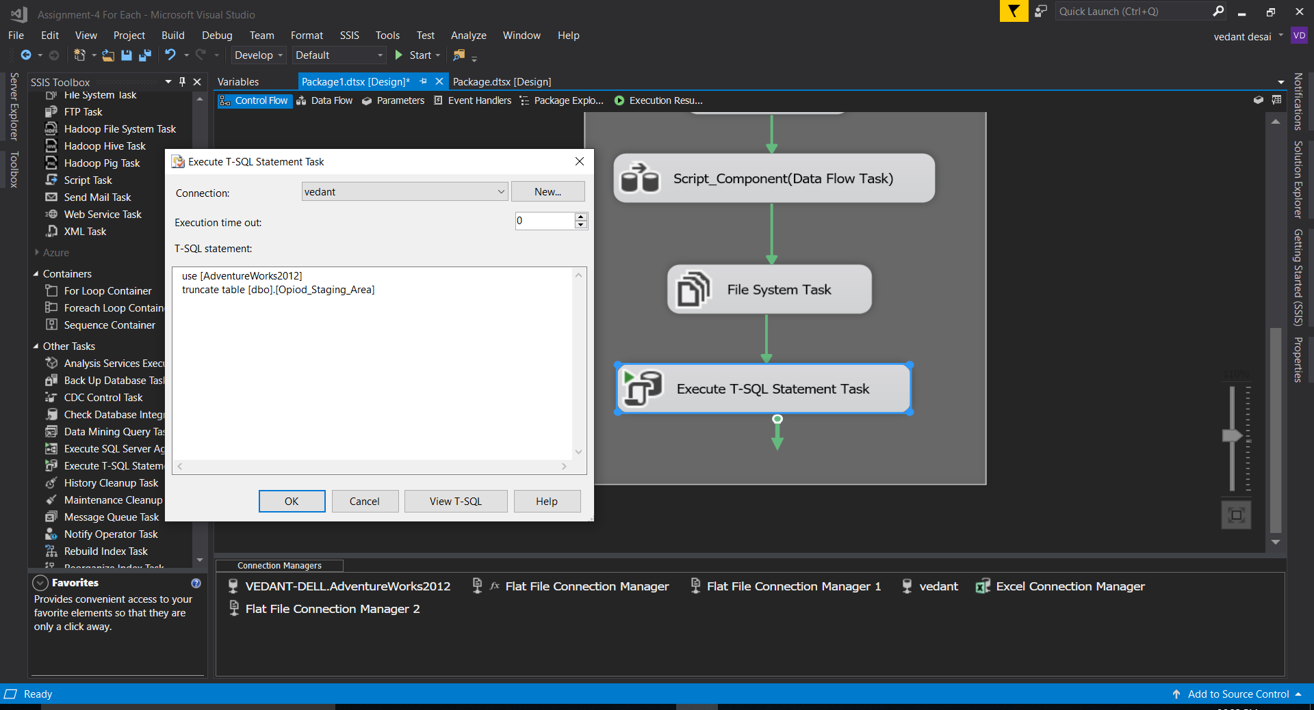

1. Preview of Table with national rows.

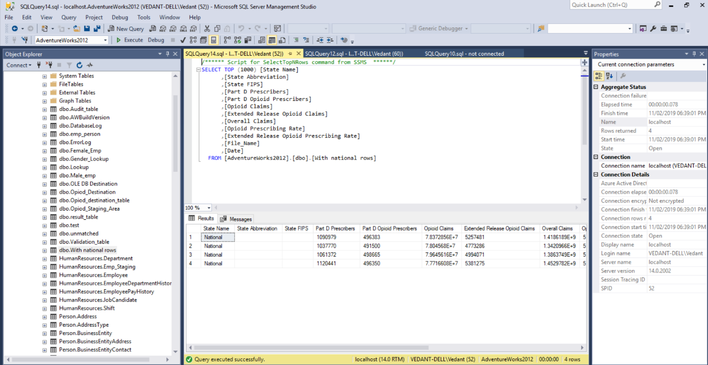

1. Preview of Opiod_destination table with two news columns and same timings.

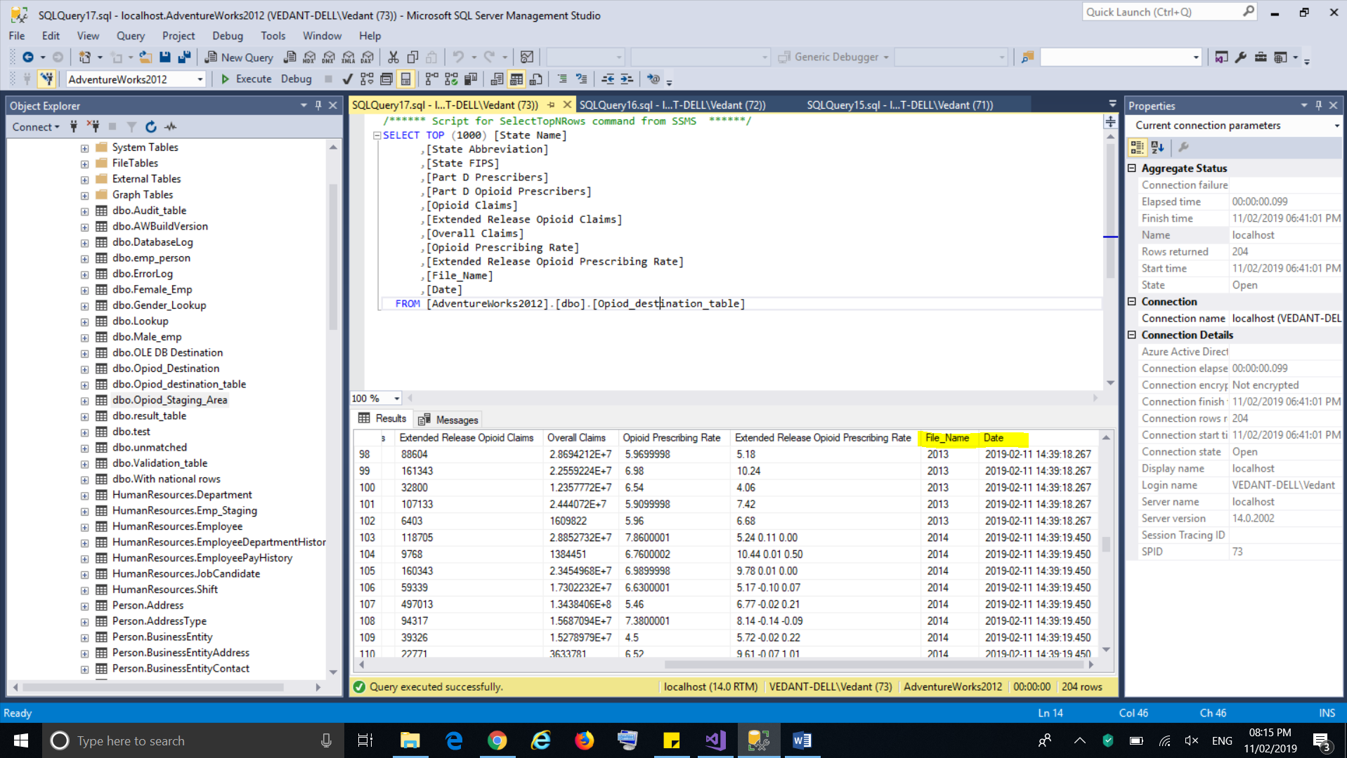

1. Preview of toad modeler.

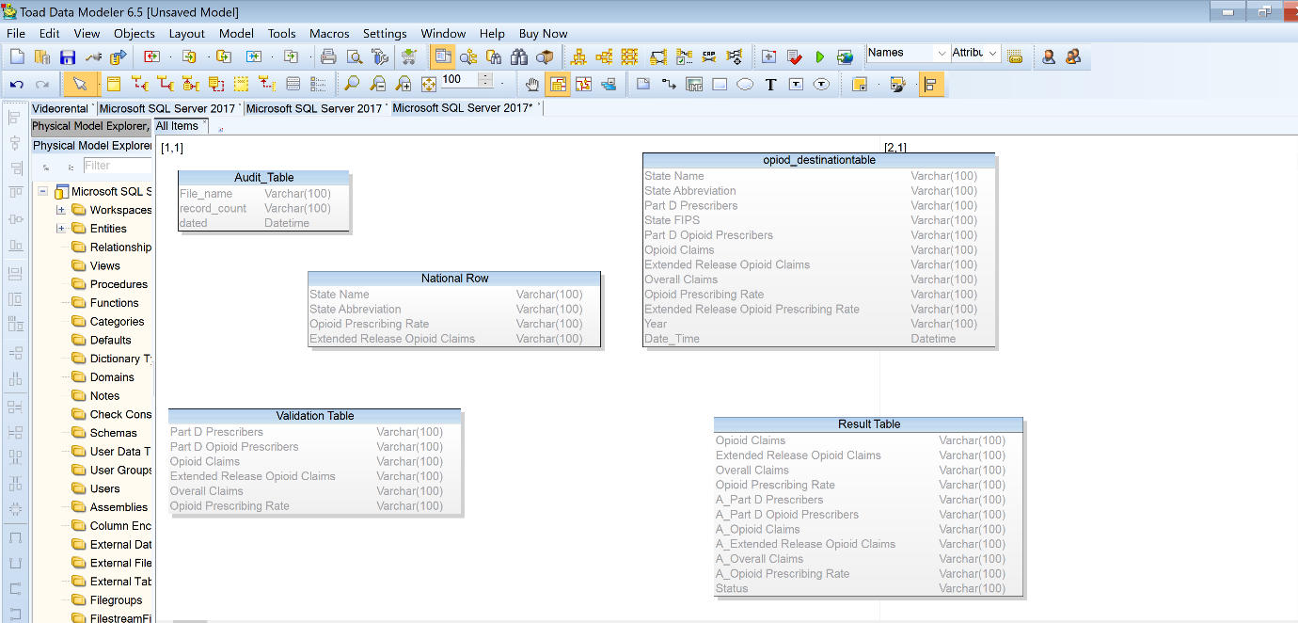

1. Overview of whole control flow in debugging mode.

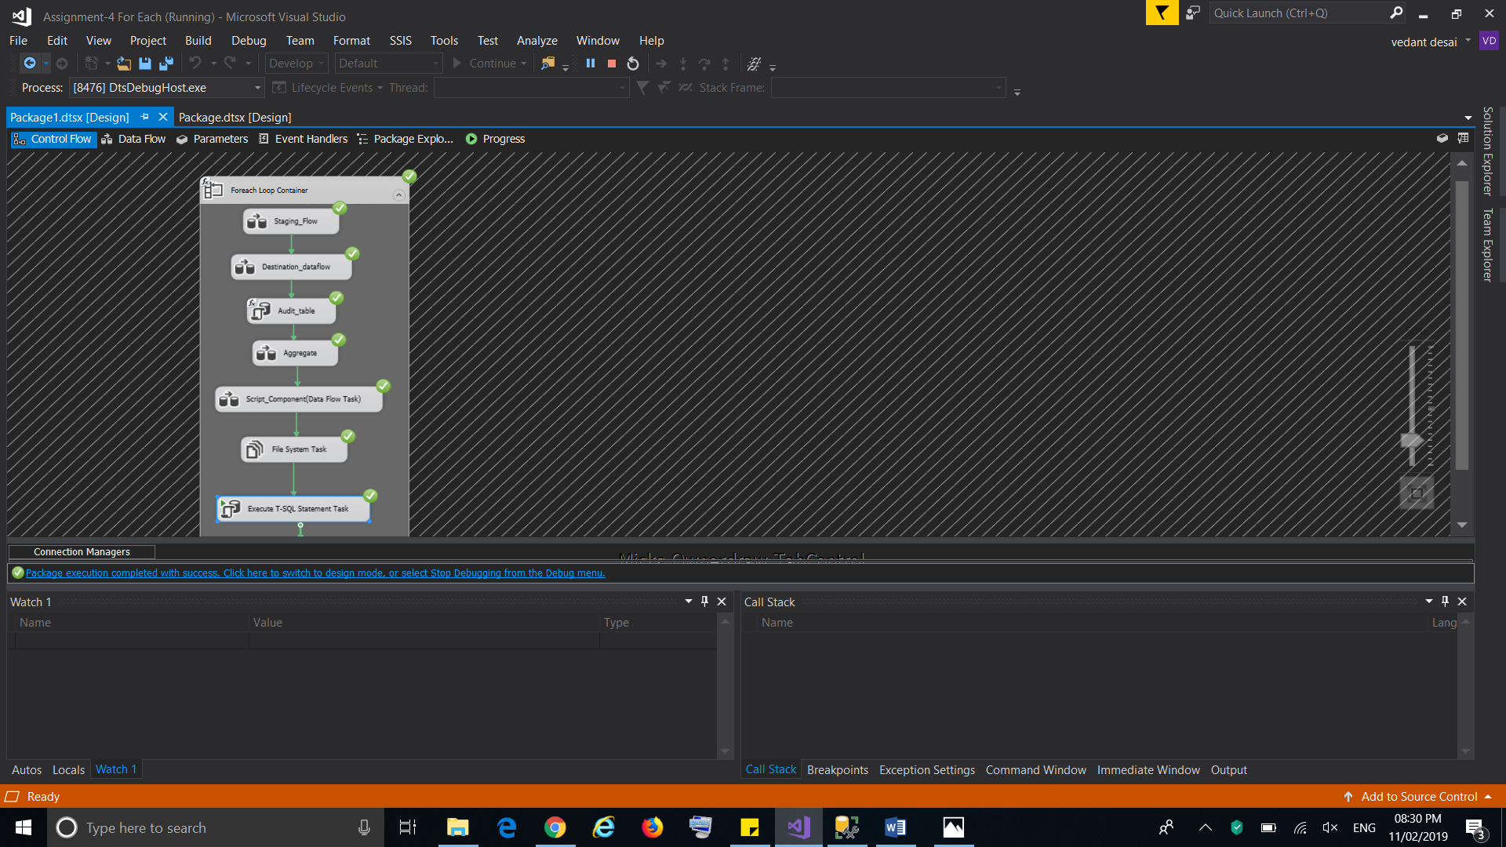

1. GITHUB Path

<https://github.com/Vedant1065/Assignment-4/>